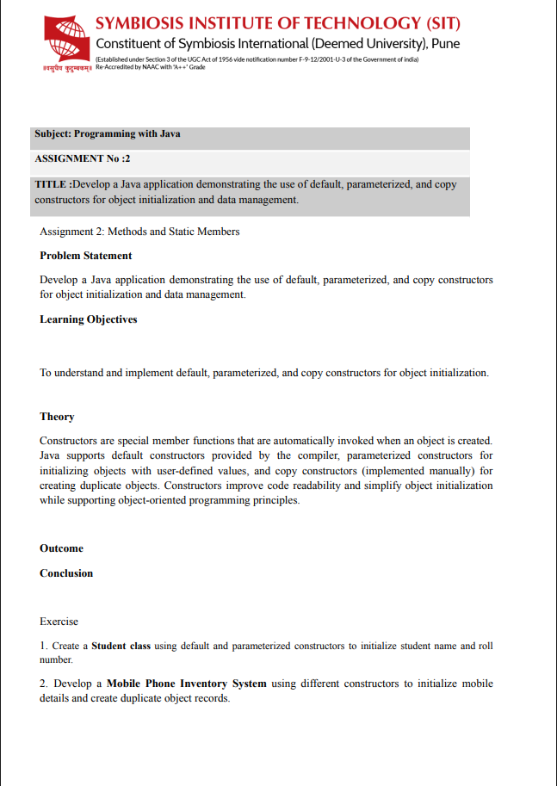
Assignment no. 2
Name: Abhyuday Tripathi
PRN: 25070122013
Batch A1
TITLE :Develop a Java application demonstrating the use of default, parameterized, and copy constructors for object initialization and data management.
Problem Statement: Develop a Java application demonstrating the use of default, parameterized, and copy constructors for object initialization and data management.
Learning Objectives: To understand and implement default, parameterized, and copy constructors for object initialization.
Theory
Constructors are special member functions that are automatically invoked when an object is created. Java supports default constructors provided by the compiler, parameterized constructors for initializing objects with user-defined values, and copy constructors (implemented manually) for creating duplicate objects. Constructors improve code readability and simplify object initialization while supporting object-oriented programming principles.
Types of Constructors
1. Default Constructor
- Has no parameters.
- Initializes objects with default values.
2. Parameterized Constructor
- Accepts parameters.
- Initializes objects with user-defined values.
3. Copy Constructor
- Java does not provide a built-in copy constructor.
- It is created manually by passing an object of the same class to another constructor.
- Used to create a duplicate object.

Outcome:

1.Create a Student class using default and parameterized constructors to initialize student name and roll number
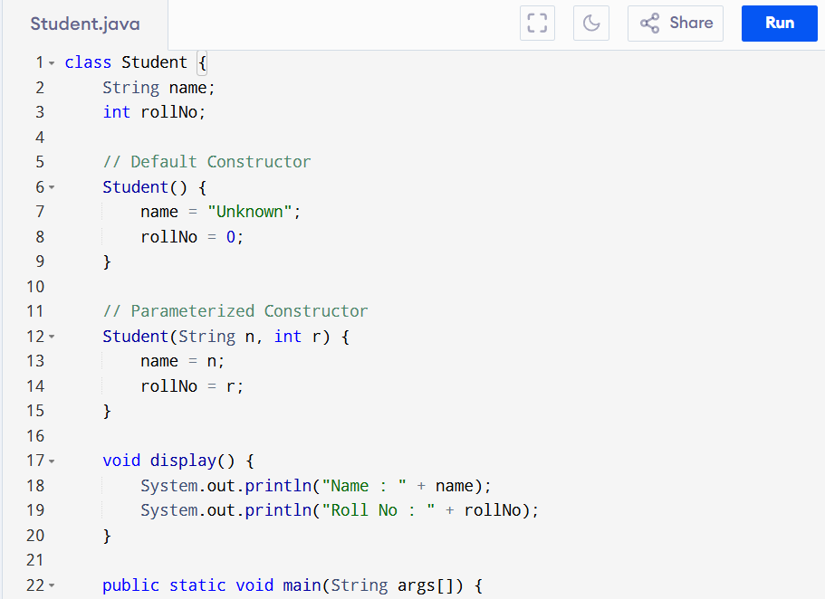
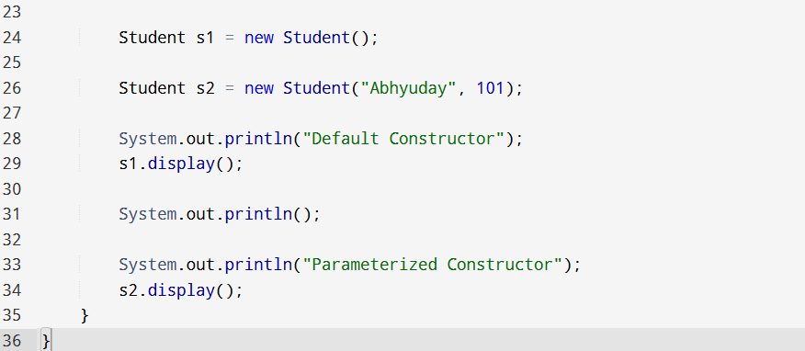
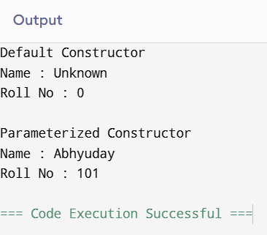
2. Develop a Mobile Phone Inventory System using different constructors to initialize mobile details and create duplicate object records.
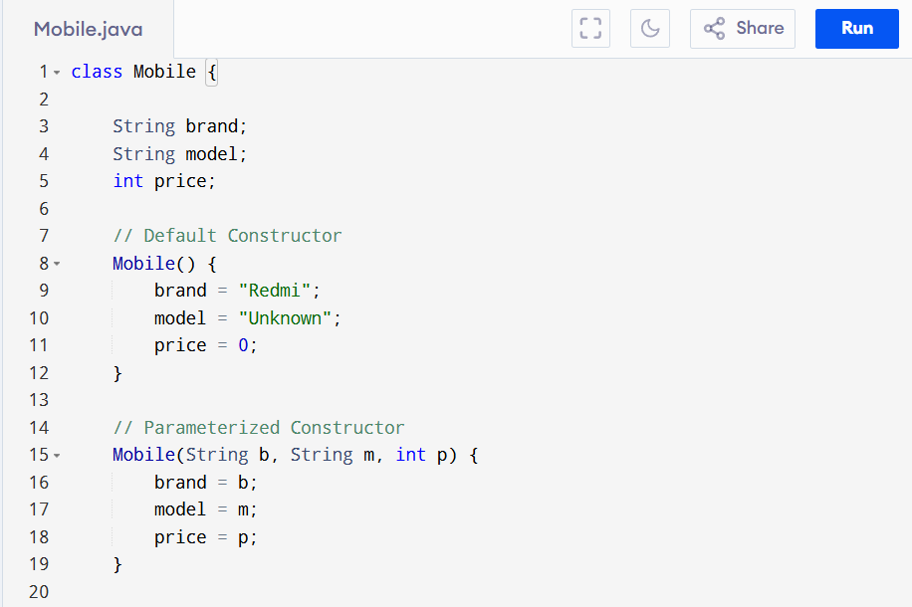
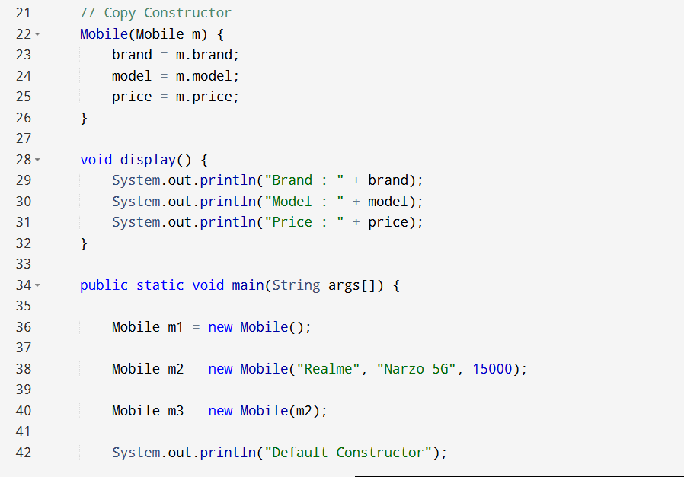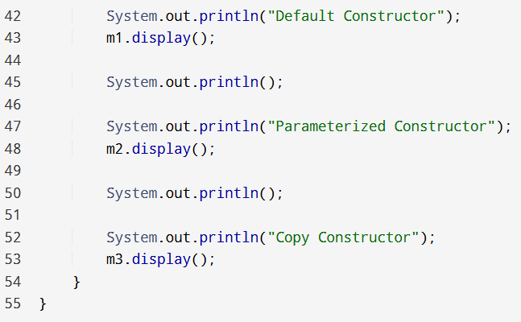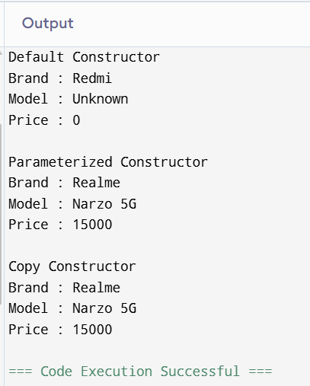

Conclusion: This assignment demonstrated the use of different types of constructors in Java. The default constructor initializes objects with predefined values, the parameterized constructor allows user-defined initialization, and the copy constructor creates duplicate objects.

